Music Library Final

By Clara Mueller

My project was a collection management style database, focusing on cataloging songs, albums, and band and band member information to create a music database. My inspiration for this project was the website The Metal Archives, which is a massive database specifically for the metal genre that contains entries for over 100 thousand different metal bands. I created four main tables with two intersection tables, and three different parent child relationships.

The BAND table keeps track of all the bands stored in the database, the INDIVIDUAL_ARTISTS table, a child of the BAND table, keeps track of members of those bands. The ALBUM table is all the albums by one of the bands from the BAND table that are in the database. BAND is the parent for the child ALBUM table. For instance, the band Dark Tranquility has two albums in my database, Fiction and Construct. The SONGS table contains all the songs that are on the ALBUM table.

Here is what it looks like:

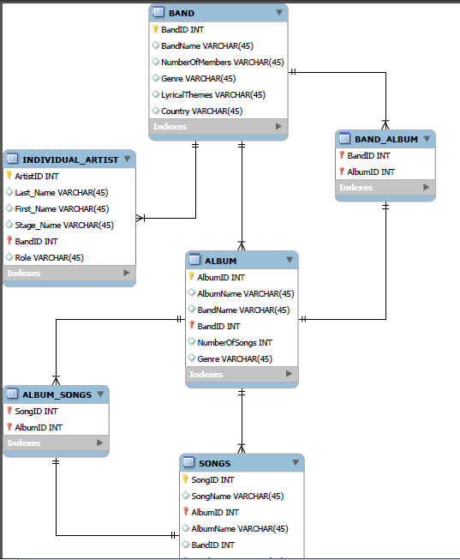

The database via the web app can add entries to BAND, ALBUM, and SONGS, and let you search for songs using keywords for anything in these tables, you can type “Mundane and the Magic” in the search to find the song by Dark Tranquility from the SONGS table, or type “Dark Tranquility” to bring up all the songs by “Dark Tranquility” in the database.

This database actually contains a total of 116 songs to search from, between 10 different bands.

In a separate search titled GetBandMember you can search for individual band members.

Here’s what each table looks like:

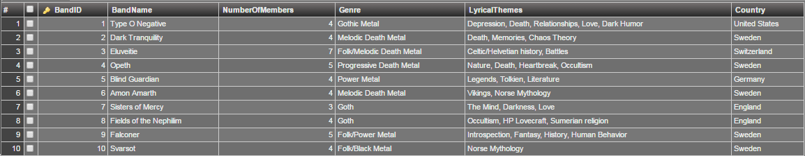

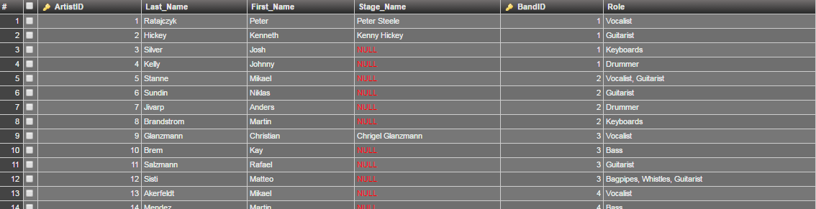

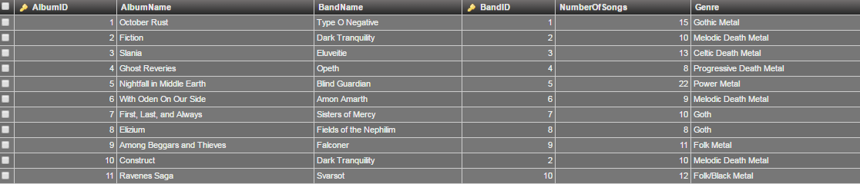

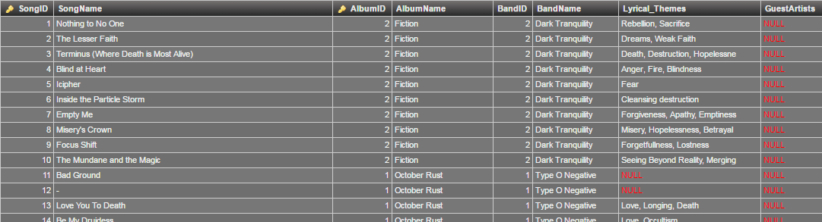

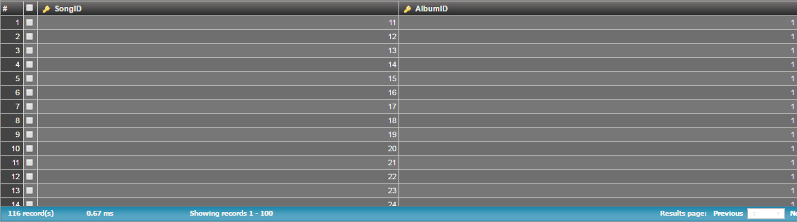

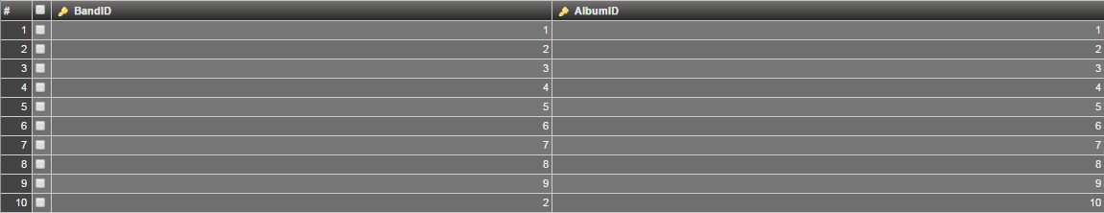

Pasted below is all of my code. First are the tables.

create table BAND(  
BandID integer,  
BandName char(100),   
NumberOfMembers integer,  
Genre char(100),

LyricalThemes char(100),

Country char(100),   
CONSTRAINT BAND_PK PRIMARY KEY(BandID)  
);

create table BAND_ALBUM(

BandID int,

AlbumID int,

PRIMARY KEY(BandID, AlbumID),

CONSTRAINT BAND_RELATIONSHIP2 FOREIGN KEY(BandID)

References BAND (BandID),

CONSTRAINT ALBUM_RELATIONSHIP2 FOREIGN KEY(AlbumID)

References ALBUM (AlbumID)  
);

create table ALBUM (  
AlbumID int,  
AlbumName char(100),   
BandName char (100),  
BandID int,  
CONSTRAINT Band_Album FOREIGN KEY(BandID)  
REFERENCES BAND(BandID),  
NumberOfSongs int,  
Genre char(100),   
CONSTRAINT ALBUM_PK PRIMARY KEY(AlbumID, BandID)  
);

create table BAND_ARTIST(  
CONSTRAINT BAND_RELATIONSHIP2 FOREIGN KEY(BandID)

References BAND (BandID),

CONSTRAINT ARTIST_RELATIONSHIP2 FOREIGN KEY(ArtistID)

References INDIVIDUAL_ARTIST (ArtistID)  
);

create table INDIVIDUAL_ARTIST (  
ArtistID integer,

Last_Name char(100),

First_Name char (100),

Stage_Name char (100),

BandID int,   
CONSTRAINT INDIVIDUAL_ARTIST_STUFF FOREIGN KEY(BandID)

References BAND (BandID),  
Role char(40),  
CONSTRAINT INDIVIDUAL_ARTIST_PK PRIMARY KEY(ArtistID, BandID)  
);

create table ALBUM_SONGS(  
 SongID int,  
  AlbumID int,

PRIMARY KEY (SongID, AlbumID),  
CONSTRAINT SONG_RELATIONSHIP3 FOREIGN KEY(SongID)  
REFERENCES SONGS (SongID),  
CONSTRAINT ALBUM_RELATIONSHIP3 FOREIGN KEY(AlbumID)  
REFERENCES ALBUM (AlbumID)  
);

create table SONGS (  
SongID integer,

SongName char(100),

AlbumID int,

CONSTRAINT SONG_RELATIONSHIP FOREIGN KEY(AlbumID)

References ALBUM (AlbumID),

AlbumName char(100),

BandID int,

CONSTRAINT BAND_RELATIONSHIP FOREIGN KEY(BandID)

References BAND (BandID),

BandName char(100),  
Lyrical_Themes char(30),   
GuestArtists char(40),  
CONSTRAINT SONGS_NEW_PK PRIMARY KEY(SongID, AlbumID)   
);

Second, are the procedures.

CREATE DEFINER=`muellec`@`violeta.simmons.edu` PROCEDURE `add_band`(BandID int, BandName char(100), NumberOfMembers int, Genre char(100), LyricalThemes char(100), Country char(100))  
BEGIN  
INSERT INTO BAND (BandID, BandName, NumberOfMembers, Genre, LyricalThemes, Country) VALUES(  
 BandID, BandName, NumberOfMembers, Genre, LyricalThemes, Country);   
END

create procedure add_album (AlbumID int, AlbumName char(100), BandName char(100), BandID int, NumberOfSongs int, Genre char(100))   
BEGIN  
INSERT INTO ALBUM (AlbumID, AlbumName, BandName, BandID, NumberOfSongs, Genre) VALUES(  
 AlbumID, AlbumName, BandName, BandID, NumberOfSongs, Genre);    
END

create procedure add_songs (SongID int, SongName char(100), AlbumID int, AlbumName char(100), BandID int, BandName char(100), Lyrical_Themes char(100), GuestArtistschar(100))   
BEGIN  
INSERT INTO SONGS (SongID, SongName, AlbumID, AlbumName, BandID, BandName, Lyrical_Themes, GuestArtists) VALUES(  
 SongID, SongName, AlbumID, AlbumName, BandID, BandName, Lyrical_Themes, GuestArtists);    
END

create procedure GetSong (Keyword CHAR (100))  
  BEGIN  
  select SongName, AlbumName, BandName, Lyrical_Themes, GuestArtists  
  from SONGS  
  where BandName like concat("%",Keyword,"%")  
or  AlbumName like concat("%",Keyword,"%")  
or  SongName like concat("%",Keyword,"%");  
    
  END;

create procedure GetBandMember(Keyword CHAR (100))  
  BEGIN  
  select First_Name, Last_Name, Stage_Name, Role, ii.BandName  
  from INDIVIDUAL_ARTIST i  
  join BAND ii  
  on i.BandID = ii.BandID  
  where First_Name like concat("%",Keyword,"%")  
  or Last_Name like concat("%",Keyword,"%")  
;  
    
  END;

<html>

<head>

<title>Search Database</title>

<style>

h2 {text-align:center; color: blue;}

h4 { color:blue;}

input { margin: 5px;}

</style>

</head>

<body>

<h2>Search Music Library.</h2>

<form id="formName" name="formName"

method = 'post'

action ="GetSong.php">

<!--text box -->

<h4><em>Type Search Term</em></h4>

<input type="text" name="Keyword" id="Keyword" value="" size="30" /><br />

<!-- A submit button will send the form, via get or post, to php file specified in the form tag -->

<input type="submit" name="sButton" value="Enter Search" />

</form>

</body>

</html>

<HTML>

<HEAD>

<TITLE> Music Collection</TITLE>

</HEAD>

<BODY>

<?php

include 'printTable.php';

$host = 'dany.simmons.edu';

$user = 'muellec';

$password = '1655681';

$database = '33302sp16_muellec';

echo "Server Name " .$host ."<br/><br/>";

echo 'Attempting to connect to server <br/><br/>';

$conn = mysql_connect($host,$user,$password) or die('unable to connect' . mysql_error($conn));

echo 'Successfully connected to server';

echo "<br/><br/>";

echo "Database name: ". $database . "<br/><br>";

echo 'Attempting to connect to database <br/><br/>';

mysql_select_db($database,$conn) or die ('unable' . msql_error($conn));

echo "Connected to database " . $database;

// repeat query: Add Song to Database

echo "<br/><br/>";

echo " POST info: <br/>";

$Keyword = $_POST["Keyword"];

echo $Keyword ." <br/>";

$sql = "CALL GetSong('$Keyword')";

echo $sql ."<br/>";

$result = mysql_query($sql);

// (1) print out each row (3 cols) from the sql results in a nice html table

echo ("<TABLE border=2>");

while($row=mysql_fetch_row($result)){

echo("<TR>");

echo("<TD>".$row[0]."</TD>");

echo("<TD>".$row[1]."</TD>");

echo("<TD>".$row[2]."</TD>");

echo("<TD>".$row[3]."</TD>");

echo("<TD>".$row[4]."</TD>");

echo("</TR>");

}

echo "</TABLE>";

// (2) print out each row (unspecified # of cols) from the sql results in a nice html table

echo ("<h2> Results </h2>");

$result1 = mysql_query($sql);

echo ("<TABLE border=2>");

while($row=mysql_fetch_row($result1)){

echo("<TR>");

for($j=0;$j<mysql_num_fields($result1);$j++){

echo("<TD>".$row[$j]."</TD>");

}

echo("</TR>");

}

echo "</TABLE>";

//$sql_1 = "select * from BAND";

//$result_1 = mysql_query($sql_1);

printTable($result);

?>

</body>

<HTML>

<HEAD>

<TITLE> Music Collection</TITLE>

</HEAD>

<BODY>

<?php

include 'printTable.php';

$host = 'dany.simmons.edu';

$user = 'muellec';

$password = '1655681';

$database = '33302sp16_muellec';

echo "Server Name " .$host ."<br/><br/>";

echo 'Attempting to connect to server <br/><br/>';

$conn = mysql_connect($host,$user,$password) or die('unable to connect' . mysql_error($conn));

echo 'Successfully connected to server';

echo "<br/><br/>";

echo "Database name: ". $database . "<br/><br>";

echo 'Attempting to connect to database <br/><br/>';

mysql_select_db($database,$conn) or die ('unable' . msql_error($conn));

echo "Connected to database " . $database;

// repeat query: Gets BandMember

echo "<br/><br/>";

echo " POST info: <br/>";

$Keyword = $_POST["Keyword"];

echo $Keyword ." <br/>";

$sql = "CALL GetBandMember('$Keyword')";

echo $sql ."<br/>";

$result = mysql_query($sql);

// (1) print out each row (3 cols) from the sql results in a nice html table

echo ("<TABLE border=2>");

while($row=mysql_fetch_row($result)){

echo("<TR>");

echo("<TD>".$row[0]."</TD>");

echo("<TD>".$row[1]."</TD>");

echo("<TD>".$row[2]."</TD>");

echo("<TD>".$row[3]."</TD>");

echo("<TD>".$row[4]."</TD>");

echo("</TR>");

}

echo "</TABLE>";

// (2) print out each row (unspecified # of cols) from the sql results in a nice html table

echo ("<h2> Results </h2>");

$result1 = mysql_query($sql);

echo ("<TABLE border=2>");

while($row=mysql_fetch_row($result1)){

echo("<TR>");

for($j=0;$j<mysql_num_fields($result1);$j++){

echo("<TD>".$row[$j]."</TD>");

}

echo("</TR>");

}

echo "</TABLE>";

//$sql_1 = "select * from BAND";

//$result_1 = mysql_query($sql_1);

printTable($result);

?>

</body>

<html>

<head>

<title>Search Database For Band Member</title>

<style>

h2 {text-align:center; color: blue;}

h4 { color:blue;}

input { margin: 5px;}

</style>

</head>

<body>

<h2>Search Music Library.</h2>

<form id="formName" name="formName"

method = 'post'

action ="GetBandMember.php">

<!--text box -->

<h4><em>Type Search Term</em></h4>

<input type="text" name="Keyword" id="Keyword" value="" size="30" /><br />

<!-- A submit button will send the form, via get or post, to php file specified in the form tag -->

<input type="submit" name="sButton" value="Enter Search" />

</form>

</body>

</html>

<HTML>

<HEAD>

<TITLE> Music Collection</TITLE>

</HEAD>

<BODY>

<?php

include 'printTable.php';

$host = 'dany.simmons.edu';

$user = 'muellec';

$password = '1655681';

$database = '33302sp16_muellec';

echo "Server Name " .$host ."<br/><br/>";

echo 'Attempting to connect to server <br/><br/>';

$conn = mysql_connect($host,$user,$password) or die('unable to connect' . mysql_error($conn));

echo 'Successfully connected to server';

echo "<br/><br/>";

echo "Database name: ". $database . "<br/><br>";

echo 'Attempting to connect to database <br/><br/>';

mysql_select_db($database,$conn) or die ('unable' . msql_error($conn));

echo "Connected to database " . $database;

// repeat query: Add Song to Database

echo "<br/><br/>";

echo " POST info: <br/>";

$BandID = $_POST["BandID"];

echo $BandID ." <br/>";

$BandName = $_POST["BandName"];

echo $BandName ." <br/>";

$NumberOfMembers = $_POST["NumberOfMembers"];

echo $NumberOfMembers ." <br/>";

$Genre = $_POST["Genre"];

echo $Genre ." <br/>";

$LyricalThemes = $_POST["LyricalThemes"];

echo $LyricalThemes ." <br/>";

$Country = $_POST["Country"];

echo $Country ." <br/>";

$sql = "CALL add_band('$BandID','$BandName', '$NumberOfMembers', '$Genre',

'$LyricalThemes', '$Country')";

echo $sql ."<br/>";

$result = mysql_query($sql);

// (1) print out each row (3 cols) from the sql results in a nice html table

echo ("<TABLE border=2>");

while($row=mysql_fetch_row($result)){

echo("<TR>");

echo("<TD>".$row[0]."</TD>");

echo("<TD>".$row[1]."</TD>");

echo("<TD>".$row[2]."</TD>");

echo("<TD>".$row[3]."</TD>");

echo("<TD>".$row[4]."</TD>");

echo("</TR>");

}

echo "</TABLE>";

// (2) print out each row (unspecified # of cols) from the sql results in a nice html table

echo ("<h2> Bands </h2>");

$result1 = mysql_query($sql);

echo ("<TABLE border=2>");

while($row=mysql_fetch_row($result1)){

echo("<TR>");

for($j=0;$j<mysql_num_fields($result1);$j++){

echo("<TD>".$row[$j]."</TD>");

}

echo("</TR>");

}

echo "</TABLE>";

<html>

<head>

<title>Add Band</title>

<style>

h2 {text-align:center; color: blue;}

h4 { color:blue;}

input { margin: 5px;}

</style>

</head>

<body>

<h2>Please fill in the information for the new band.</h2>

<form id="formName" name="formName"

method = 'post'

action ="addBand.php">

<!--text box -->

<h4><em>BandID</em></h4>

<input type="text" name="BandID" id="BandID" value="" size="30" /><br />

<h4><em>BandName</em></h4>

<input type="text" name="BandName" id="BandName" value="" size="30" /><br />

<h4><em>NumberOfMembers</em></h4>

<input type="text" name="NumberOfMembers" id="NumberOfMembers" value="" size="30" /><br />

<h4><em>Genre</em></h4>

<input type="text" name="Genre" id="Genre" value="" size="30" /><br />

<h4><em>LyricalThemes</em></h4>

<input type="text" name="LyricalThemes" id="LyricalThemes" value="" size="30" /><br />

<h4><em>Country</em></h4>

<input type="text" name="Country" id="Country" value="" size="30" /><br />

<!-- A submit button will send the form, via get or post, to php file specified in the form tag -->

<input type="submit" name="sButton" value="Enter Band" />

</form>

</body>

</html>

$host = 'dany.simmons.edu';

$user = 'muellec';

$password = '1655681';

$database = '33302sp16_muellec';

echo "Server Name " .$host ."<br/><br/>";

echo 'Attempting to connect to server <br/><br/>';

$conn = mysql_connect($host,$user,$password) or die('unable to connect' . mysql_error($conn));

echo 'Successfully connected to server';

echo "<br/><br/>";

echo "Database name: ". $database . "<br/><br>";

echo 'Attempting to connect to database <br/><br/>';

mysql_select_db($database,$conn) or die ('unable' . msql_error($conn));

echo "Connected to database " . $database;

// repeat query: Add Album to Database

echo "<br/><br/>";

echo " POST info: <br/>";

$AlbumID = $_POST["AlbumID"];

echo $AlbumID ." <br/>";

$AlbumName = $_POST["AlbumName"];

echo $AlbumName ." <br/>";

$BandName = $_POST["BandName"];

echo $BandName ." <br/>";

$BandID = $_POST["BandID"];

echo $BandID ." <br/>";

$NumberOfSongs = $_POST["NumberOfSongs"];

echo $NumberOfSongs ." <br/>";

$Genre = $_POST["Genre"];

echo $Genre ." <br/>";

$sql = "CALL add_album('$AlbumID','$AlbumName', '$BandName', '$BandID',

'$NumberOfSongs', '$Genre')";

echo $sql ."<br/>";

$result = mysql_query($sql);

// (1) print out each row (3 cols) from the sql results in a nice html table

echo ("<TABLE border=2>");

while($row=mysql_fetch_row($result)){

echo("<TR>");

echo("<TD>".$row[0]."</TD>");

echo("<TD>".$row[1]."</TD>");

echo("<TD>".$row[2]."</TD>");

echo("<TD>".$row[3]."</TD>");

echo("<TD>".$row[4]."</TD>");

echo("</TR>");

}

echo "</TABLE>";

// (2) print out each row (unspecified # of cols) from the sql results in a nice html table

echo ("<h2> Albums </h2>");

$result1 = mysql_query($sql);

echo ("<TABLE border=2>");

while($row=mysql_fetch_row($result1)){

echo("<TR>");

for($j=0;$j<mysql_num_fields($result1);$j++){

echo("<TD>".$row[$j]."</TD>");

}

echo("</TR>");

}

echo "</TABLE>";

$sql_1 = "select * from ALBUM";

$result_1 = mysql_query($sql_1);

printTable($result_1);

?>

</body>

</html>

input { margin: 5px;}

</style>

</head>

<body>

<h2>Please fill in the information for the new album.</h2>

<form id="formName" name="formName"

method = 'post'

action ="addAlbum.php">

<!--text box -->

<h4><em>AlbumID</em></h4>

<input type="text" name="AlbumID" id="AlbumID" value="" size="100" /><br />

<h4><em>AlbumName</em></h4>

<input type="text" name="AlbumName" id="AlbumName" value="" size="100" /><br />

<h4><em>BandName</em></h4>

<input type="text" name="BandName" id="BandName" value="" size="100" /><br />

<h4><em>BandID</em></h4>

<input type="text" name="BandID" id="BandID" value="" size="100" /><br />

<h4><em>NumberOfSongs</em></h4>

<input type="text" name="NumberOfSongs" id="NumberOfSongs" value="" size="100" /><br />

<h4><em>Genre</em></h4>

<input type="text" name="Genre" id="Genre" value="" size="100" /><br />

<!-- A submit button will send the form, via get or post, to php file specified in the form tag -->

<input type="submit" name="sButton" value="Enter Band" />

</form>

</body>

</html>

<html>

<head>

<title>Add Band</title>

<style>

h2 {text-align:center; color: blue;}

h4 { color:blue;}

input { margin: 5px;}

</style>

</head>

<body>

<h2>Please fill in the information for the new song.</h2>

<form id="formName" name="formName"

method = 'post'

action ="addSong.php">

<!--text box -->

<h4><em>BandID</em></h4>

<input type="text" name="BandID" id="BandID" value="" size="30" /><br />

<h4><em>SongName</em></h4>

<input type="text" name="SongName" id="SongName" value="" size="30" /><br />

<h4><em>AlbumID</em></h4>

<input type="text" name="AlbumID" id="AlbumID" value="" size="30" /><br />

<h4><em>AlbumName</em></h4>

<input type="text" name="AlbumName" id="AlbumName" value="" size="30" /><br />

<h4><em>BandID</em></h4>

<input type="text" name="BandID" id="BandID" value="" size="30" /><br />

<h4><em>BandName</em></h4>

<input type="text" name="BandName" id="BandName" value="" size="30" /><br />

<h4><em>Lyrical_Themes</em></h4>

<input type="text" name="Lyrical_Themes" id="LyricalT_hemes" value="" size="30" /><br />

<h4><em>GuestArtists</em></h4>

<input type="text" name="GuestArtists" id="GuestArtists" value="" size="30" /><br />

<!-- A submit button will send the form, via get or post, to php file specified in the form tag -->

<input type="submit" name="sButton" value="Enter Band" />

</form>

</body>

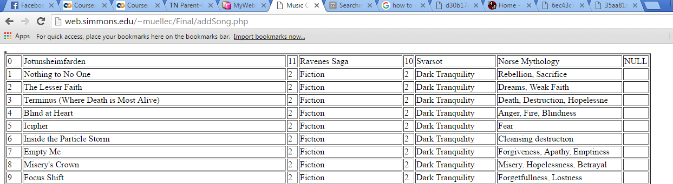

Query that adds Song, the others return similarly and simply add things to the database.

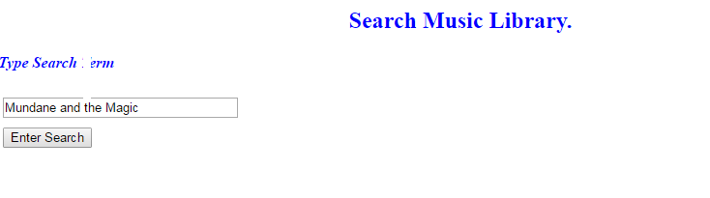

The screen shot deleted part of the “T” but here is the search,

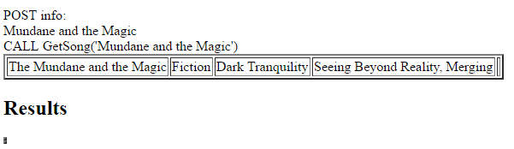

And here are the results for the query.